|  |  |
| --- | --- |
| Activity | Data Type |
| Number of beatings from Wife | Discrete |
| Results of rolling a dice | Discrete |
| Weight of a person | Continuous |
| Weight of Gold | Continuous |
| Distance between two places | Continuous |
| Length of a leaf | Continuous |
| Dog's weight | Continuous |
| Blue Color | Discrete |
| Number of kids | Discrete |
| Number of tickets in Indian railways | Discrete |
| Number of times married | Discrete |
| Gender (Male or Female) | Discrete |

1) Identify the Data type for the Following:

2) Identify the Data types, which were among the following

Nominal, Ordinal, Interval, Ratio.

|  |  |
| --- | --- |
| Data | Data Type |
| Gender | Nominal |
| High School Class Ranking | Ordinal |
| Celsius Temperature | Interval |
| Weight | Ratio |
| Hair Color | Nominal |
| Socioeconomic Status | Ordinal |
| Fahrenheit Temperature | Interval |
| Height | Ratio |
| Type of living accommodation | Nominal |
| Level of Agreement | Ordinal |
| IQ (Intelligence Scale) | Interval |
| Sales Figures | Ratio |
| Blood Group | Nominal |
| Time Of Day | Ordinal |
| Time on a Clock with Hands | Interval |
| Number of Children | Ordinal |
| Religious Preference | Nominal |
| Barometer Pressure | Interval. |
| SAT Scores | Interval |
| Years of Education | Ratio |

3) Three Coins are tossed, find the probability that two heads and one tail are obtained?

Ans: 3/8

Explanation: -

(HHH, HHT, HTH, THH, TTH, THT, HTT, TTT)

4) Two Dice are rolled, find the probability that sum is

1. Equal to 1
2. Less than or equal to 4
3. Sum is divisible by 2 and 3

Ans: a)0 b)1/6 c) 5/36

Explanation: -

a) The probability of getting sum=1 is 0. p (1) =0

b) The probability of getting<=4 is 1/6

When we tow dies are thrown, the probability less than or equal to 4 is (1,1), (1,2), (1,3), (2,1), (3,1), Therefore

* Number of favorable outcomes=6
* Total number of possibilities=36

Probability= Number of favorable outcomes / Total number of possibilities

=6/36

=1/6

c-) The probability of getting the sum which is divisible by 2&3 is 6/36

Explanation – **Total number of possible outcomes = 36**

(1,1) (1,2) (1,3) (1,4) (1,5) (1,6)

(2,1) (2,2) (2,3) (2,4) (2,5) (2,6)

(3,1) (3,2) (3,3) (3,4) (3,5) (3,6)

(4,1) (4,2) (4,3) (4,4) (4,5) (4,6)

(5,1) (5,2) (5,3) (5,4) (5,5) (5,6)

(6,1) (6,2) (6,3) (6,4) (6,5) (6,6)

Favorable outcomes = sum is divisible by 2 and 3

Sum should be divisible by both 2 and 3

Favorable outcomes = (1, 5), (3, 3), (4, 2), (5, 1), (6, 6), (2,4)

Therefore,

Number of favorable outcomes = 6

**The probability of an event is given as:**

Probability = number of favorable outcomes / numbers of possible outcomes

Hence, the probability that sum is divisible by 2 and 3 is 6/36 i.e., 1/6

5) A bag contains 2 red, 3 green and 2 blue balls. Two balls are drawn at random. What is the probability that none of the balls drawn is blue?

Ans: Probability of getting no blue balls is 10/21

Explanation: -

Total number of balls = (R, R, G, G, G, B, B) = (2+3+2) =7.

Let “s” is the sample space.

Then, n(s)=number of ways of drawing 2 balls out of 7.

=7C2 ​ = (5×4) / (2×1)​ = 10

Let “e” is the event of drawing 2 balls, none of which is blue.

n(e) = Number of ways of drawing 2 balls out of (2 + 3) balls.

=5C2​ = (5×4) / (2×1)​ = 10

P(e)= n(e) /n(s)= 10/16

6) Calculate the Expected number of candies for a randomly selected child

Below are the probabilities of count of candies for children (ignoring the nature of the child-Generalized view)

|  |  |  |
| --- | --- | --- |
| CHILD | Candies count | Probability |
| A | 1 | 0.015 |
| B | 4 | 0.20 |
| C | 3 | 0.65 |
| D | 5 | 0.65 |
| E | 6 | 0.01 |
| F | 2 | 0.120 |

Child A – probability of having 1 candy = 0.015.

Child B – probability of having 4 candies = 0.20

Ans: Expected number of candies for a randomly selected child is 3.09

Explanation: -

= 1*0.015+4*0.20+3*0.65+5*0.65+6*0.01+2*0.120

=0.015+0.8+1.95+0.025+0.06+0.24

=3.09

7) Calculate Mean, Median, Mode, Variance, Standard Deviation, Range & comment about the values / draw inferences, for the given dataset

* For Points, Score, Weigh>

Find Mean, Median, Mode, Variance, Standard Deviation, and Range and also Comment about the values/ Draw some inferences.

Use Q7.csv file

Ans:

|  |  |  |  |
| --- | --- | --- | --- |
| NAME | POINT | SCORE | WEIGHT |
| Mean | 3.60 | 3.22 | 17.85 |
| Median | 3.70 | 3.33 | 17.71 |
| Mode | 3.914 | 3.49 | 17.65 |
| Variance | 0.29 | 0.96 | 3.91 |
| Std Derivation | 0.53 | 0.98 | 1.79 |
| Range | 2.76,4.93 | 1.513,5.424 | 14.5,22.9 |

8) Calculate Expected Value for the problem below

1. The weights (X) of patients at a clinic (in pounds), are

108, 110, 123, 134, 135, 145, 167, 187, 199

Assume one of the patients is chosen at random. What is the Expected Value of the Weight of that patient?

Ans: Expected value of weight for a random selected patient =145.33

Explanation: -

Expected value = ∑ (probability *value)

Probability of selecting each patient = 1/9

Expected value

= (1/9)108+(1/9)110+(1/9)134+(1/9)135+(1/9)145+(1/9)167

+ (1/9)187+(1/9)199

= (1/9) (108+110+ 123+ 134+ 135+ 145+ 167+ 187+ 199)

= (1/9) (1308)

=145.33

9) Calculate Skewness, Kurtosis & draw inferences on the following data

Car’s speed and distance

Use Q9_a.csv

SP and Weight (WT)

Use Q9_b.csv

Ans:

Skewness and kurtosis of car speed and distance is as follow:

Skewness=-0.111(car speed) ,0.759(distance)

Kurtosis=2.42(car speed),3.24(distance)

Skewness and kurtosis of SP and weight (WT) data are as follow:

Skewness=1.55(SP), -0.59(weight)

Kurtosis=5.72(SP),3.87(weight)

Explanation: -

Inferences of Q9_a file-

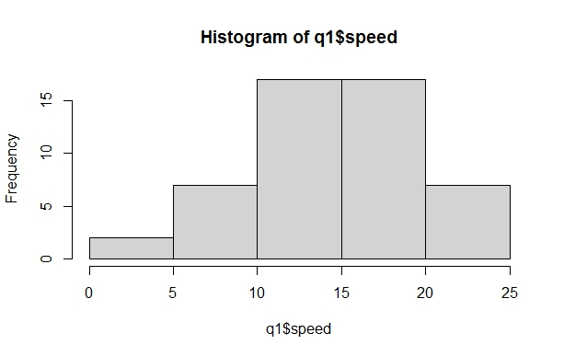

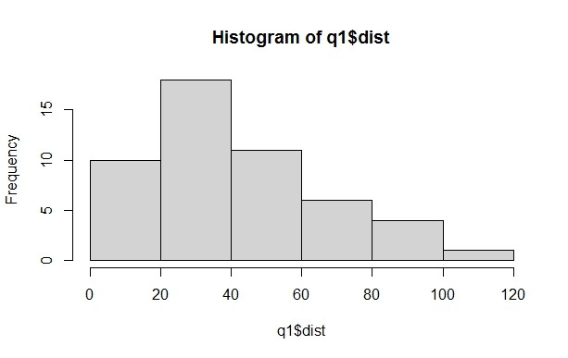

Inferences of Q9_b file-

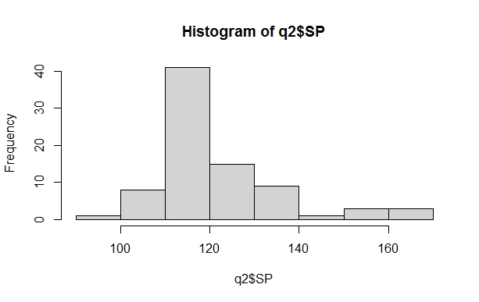

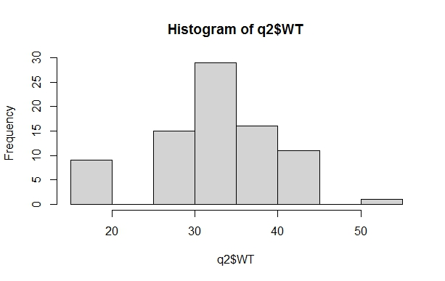

10) Draw inferences about the following boxplot & histogram





Ans:

The histogram and boxplot in Fig are positively skewed on right side.

i.e., mean and median of the data is greater than mode.

11) Suppose we want to estimate the average weight of an adult male in Mexico. We draw a random sample of 2,000 men from a population of 3,000,000 men and weigh them. We find that the average person in our sample weighs 200 pounds, and the standard deviation of the sample is 30 pounds. Calculate 94%,98%,96% confidence interval?

Ans:

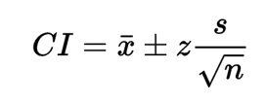 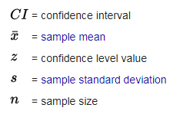

Given: x=200, s=30, n=2000

1. The 94% confidence interval is (198.739,201.62) (z=1.8808)
2. The 96% confidence interval is (198.622,201.378) (z=2.0537)
3. The 98% confidence interval is (198.439,201.561) (z=2.3263)

12) Below are the scores obtained by a student in tests

34,36,36,38,38,39,39,40,40,41,41,41,41,42,42,45,49,56

1. Find mean, median, variance, standard deviation.
2. What can we say about the student marks?

Ans:

1. Mean=41, median=40.5

Variance=25.529

Standard deviation=5.05

1. Repeatedly obtained are 36,38,40,41 and 42

Skewness =1.42

i.e., Positive.

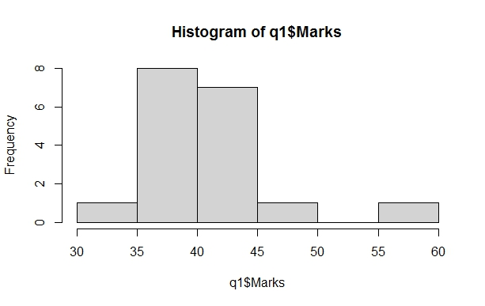

13) What is the nature of skewness when mean, median of data are equal?

Ans:

If the mean is equal to the median as well as the mode, so the skewness is zero. If the distribution is symmetric, the mean equal to median, and the skewness of the distribution is zero.

14) What is the nature of skewness when mean > median?

Ans:

If the mean is greater than the median, then distribution is positively skewed.

15) What is the nature of skewness when median > mean?

Ans:

If the mean is less than the median, the distribution is negatively skewed.

16) What does positive kurtosis value indicate for a data?

Ans: Positive value of kurtosis indicate that distribution is peaked and possesses thick tails. An extreme positive kurtosis indicates a distribution where more of the number are located in the tails of distribution instead of around the mean.

17) What does negative kurtosis value indicates for a data?

Ans: If a distribution has negative kurtosis, it is said to be platykurtic, which means that it has a flatter peak and thinner tails compared to a normal distribution. this simply means that more data value is located on the tails. Negative kurtosis is the uniform distribution, which has no peak at all and is a completely flat distribution.

18) Answer the below questions using the below boxplot visualization.



1.What can we say about the distribution of the data?

2.What is nature of skewness of the data?

3.What will be the IQR of the data (approximately)?   
  
 1. Ans: The distribution in which more values are concentrated on the right side (tail) of the graph is called Negatively Skewed Distribution, while the left tail of the distribution graph is longer  
  
2. Ans: The mean of negative skewed data will be less than the median.

3. Ans: The IQR describes the middle 50% of value when ordered from lower to highest. The interquartile range (IQR)= Q (3)- Q (1). In above example of data, the IQR = (18-10)

19) Comment on the below Boxplot visualizations?



Draw an Inference from the distribution of data for Boxplot 1 with respect Boxplot 2.

Ans: In this Fig of boxplot. Boxplot 1 is positively skewed that’s means mean and median is greater than mode. And in boxplot 2 Fig normal distribution that means the skewness for a normal distribution is zero, and any symmetric data should have a skewness near zero.

20) Calculate probability from the given dataset for the below cases

Data _set: Cars.csv

Calculate the probability of MPG of Cars for the below cases.

MPG <- Cars$MPG

* 1. P(MPG>38)
  2. P(MPG<40)

c. P(20<MPG<50)

Ans:

a) 0.3475908

b) 0.7293527

c) 0.01311818

Explanation-

a) P(MPG>38) =1-pnorm (38,34.422,9.13144) =0.348

b) P(MPG>40) =1-pnorm (40,34.422,9.13144) =0.7293527

c)P(MPG>50) =1-pnorm (50,34.422,9.13144)-

(1-pnorm (20,34.422,9.13144)) = 0.01311818

21) Check whether the data follows normal distribution

1. Check whether the MPG of Cars follows Normal Distribution

Dataset: Cars.csv

1. Check Whether the Adipose Tissue (AT) and Waist Circumference (Waist) from wc-at data set follows Normal Distribution

Dataset: wc-at.csv

a) Ans:

The MPG of Cars is highly skewed.

Skewness = -0.1746343

b) Ans: The waist data set follows normal distribution but AT doesn’t follow normal distribution

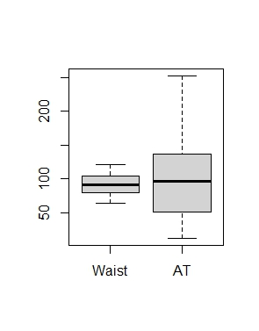

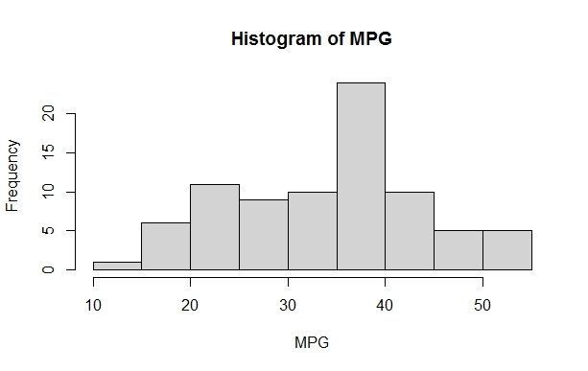

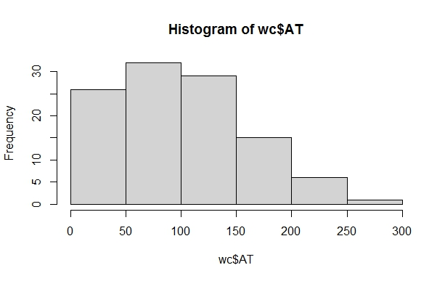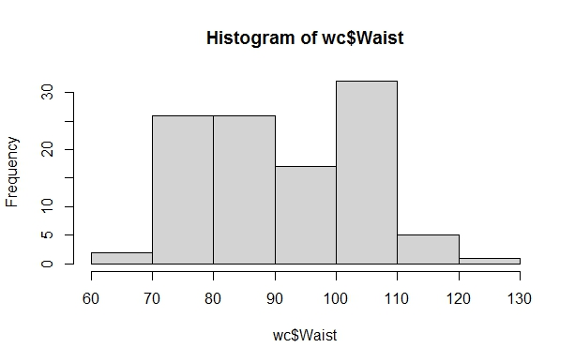

Q 22) Calculate the Z scores of 90% confidence interval,94% confidence interval, 60% confidence interval

Ans:

Z score of 60% CI = 0.84

Z score of 90% CI = 1.645

Z score of 94% CI = 1.881

Q 23) Calculate the t scores of 95% confidence interval, 96% confidence interval, 99% confidence interval for sample size of 25

Ans:

|  |  |
| --- | --- |
| Confidence Interval | T Score |
| 95% | 2.06 |
| 96% | 2.17 |
| 99% | 2.79 |

Q 24) A Government company claims that an average light bulb lasts 270 days. A researcher randomly selects 18 bulbs for testing. The sampled bulbs last an average of 260 days, with a standard deviation of 90 days. If the CEO's claim were true, what is the probability that 18 randomly selected bulbs would have an average life of no more than 260 days

Hint:

rcode 🡪 pt(tscore,df)

df 🡪 degrees of freedom

Ans:

For probability calculations, the number of degrees of freedom is n - 1, so here you need the t-distribution with 17 degrees of freedom.

The probability that t < - 0.471 with 17 degrees of freedom assuming the population mean is true, the t-value is less than the t-value obtained with 17 degrees of freedom and a t score of - 0.471, the probability of the bulbs lasting less than 260 days on average of 0.3218 assuming the mean life of the bulbs is 300 days.